Assignment – 3

Create a HeatMap Plot for the following plot with Seaborn

CODE:

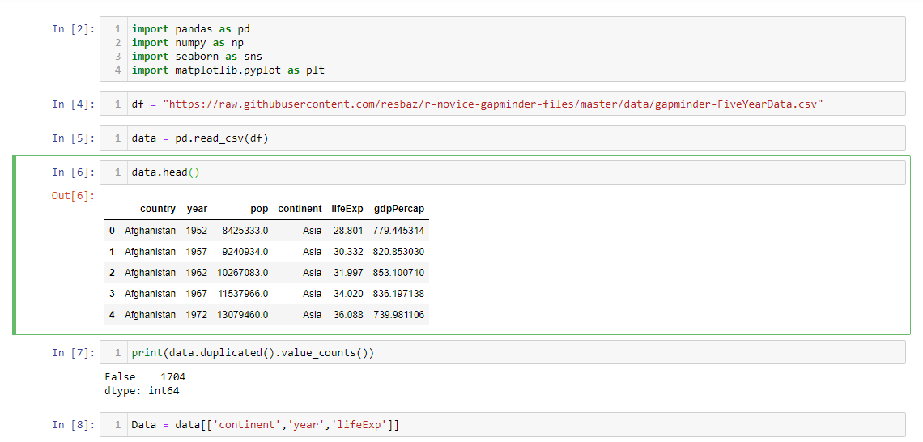

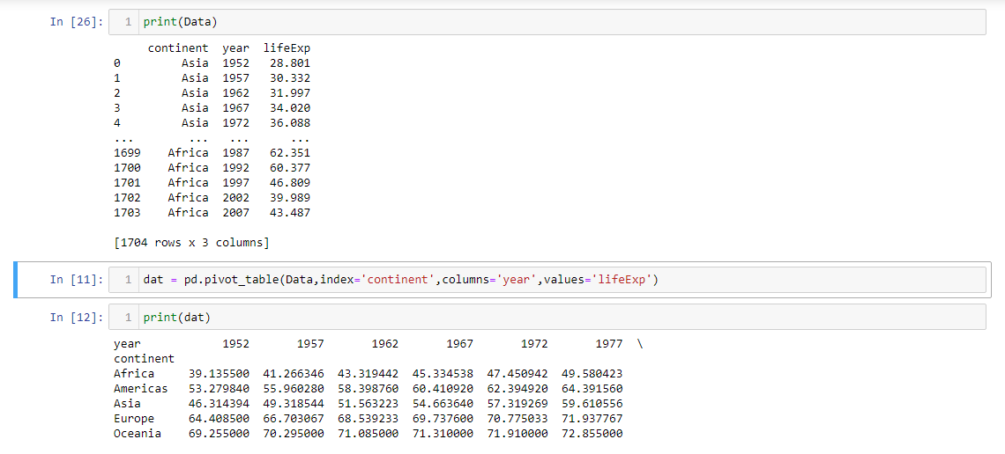

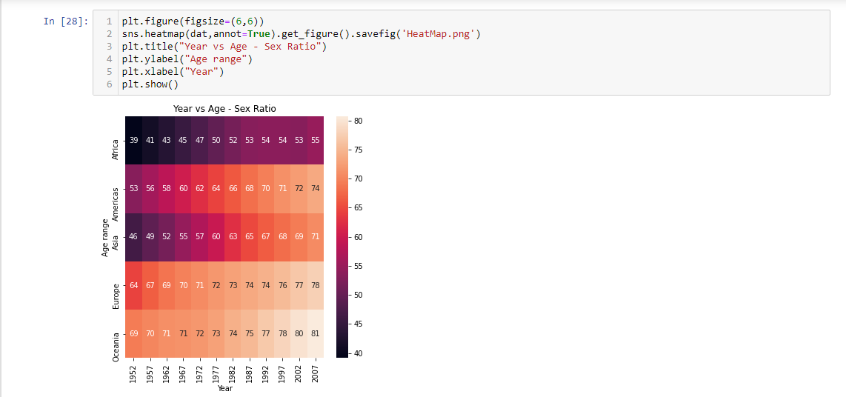

Explanation:

1. Read The dataset using read_csv() of pandas.
2. Since the Data Set was very vast, I examined it to check if there are any duplicate values. Luckily, there were no duplicate values.
3. Extracted the requires columns(continent, year and lifeExp) from the dataset into a new dataset(Data)
4. Created a pivot table from that data frame (dat) with index=continent, columns=year and values=lifeExp.
5. Heatmap of the pivot table dataframe was plotted using headmap() function of seaborn.
6. The heatmap figure was saved as HeatMap.png.